Team 1 Open Source Air Quality Monitoring

Week 22: June 5 - June 12

Sponsor: Dr. [David Burnett](mailto:dburnett@pdx.edu)

Advisor: Dr. John Acken

Team Members: [Adam Dezay](mailto:adezay@pdx.edu), [Manuel Garcia](mailto:manga2@pdx.edu), [Brandon Hippe](mailto:bhippe@pdx.edu), Mercedes Newton

**Team Review:**

* Team finished rough drafts of final report and poster
* Team built the 4th unit and conducted a successful test of all 4 units running over the weekend.
* Team finished graphing script, shown in figure two.
* Team ordered batteries to fill the sensor units with
* Questions:
  + How do we give over code and design files and documentation?
  + Where in the Lab should the sensors be put up?
  + What computer should Host Node and graphing script be run on?
  + How to host our website

**Individual Review**

Adam Dezay:

Completed report,website, poster, and github.Helped Mercedes with Latex report

Manuel Garcia:

Helped finish the assembly of the last nodes. Worked on cleaning up documentation for the end of our capstone project. Reviewed poster, and worked on writing the final report.

Brandon Hippe:

Worked to build the 4th sensor node, and ran test of all 4 nodes over the weekend. Two of the nodes stopped running, one due to a wire coming unplugged, and the other just needed to be reset. Worked to finish the graphing script. Got the ultrasonic airflow sensor detecting airflow from a fan, but found that it is unlikely it will be able to respond to the very low airflow from the vent(s) in the lab.

Mercedes Newton:

Completed LaTex conversion of final report. Reviewed poster. Submitted report to [Andrew Greenberg](mailto:adg4@pdx.edu).

**Gantt Chart and Timeline Updates:**

Below is both the timeline of the projected project progress for spring term. Figure 1 represents the gantt chart for the term with expected completion dates beginning March 25th. All specific dates for the upcoming term are specified in the table below.

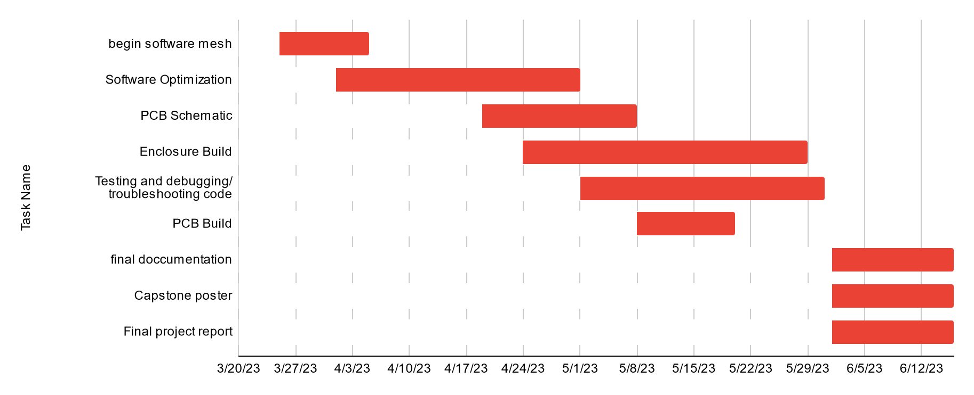

Figure One: Gantt chart for spring term (first task starts 3/25/2013)

| Task Name | Start date | End date |
| --- | --- | --- |
| Begin software mesh | 3/25/2023 | 4/5/2023 |
| Software Optimization | 4/1/2023 | 5/1/2023 |
| PCB Schematic | 4/19/2023 | 5/8/2023 |
| Enclosure Build | 4/24/2023 | 5/29/2023 |
| Testing and debugging/ troubleshooting code | 5/1/2023 | 5/31/2023 |
| PCB Build | 5/8/2023 | 5/20/2023 |
| final documentation | 6/1/2023 | 6/16/2023 |
| Capstone poster | 6/1/2023 | 6/16/2023 |
| Final project report | 6/1/2023 | 6/16/2023 |

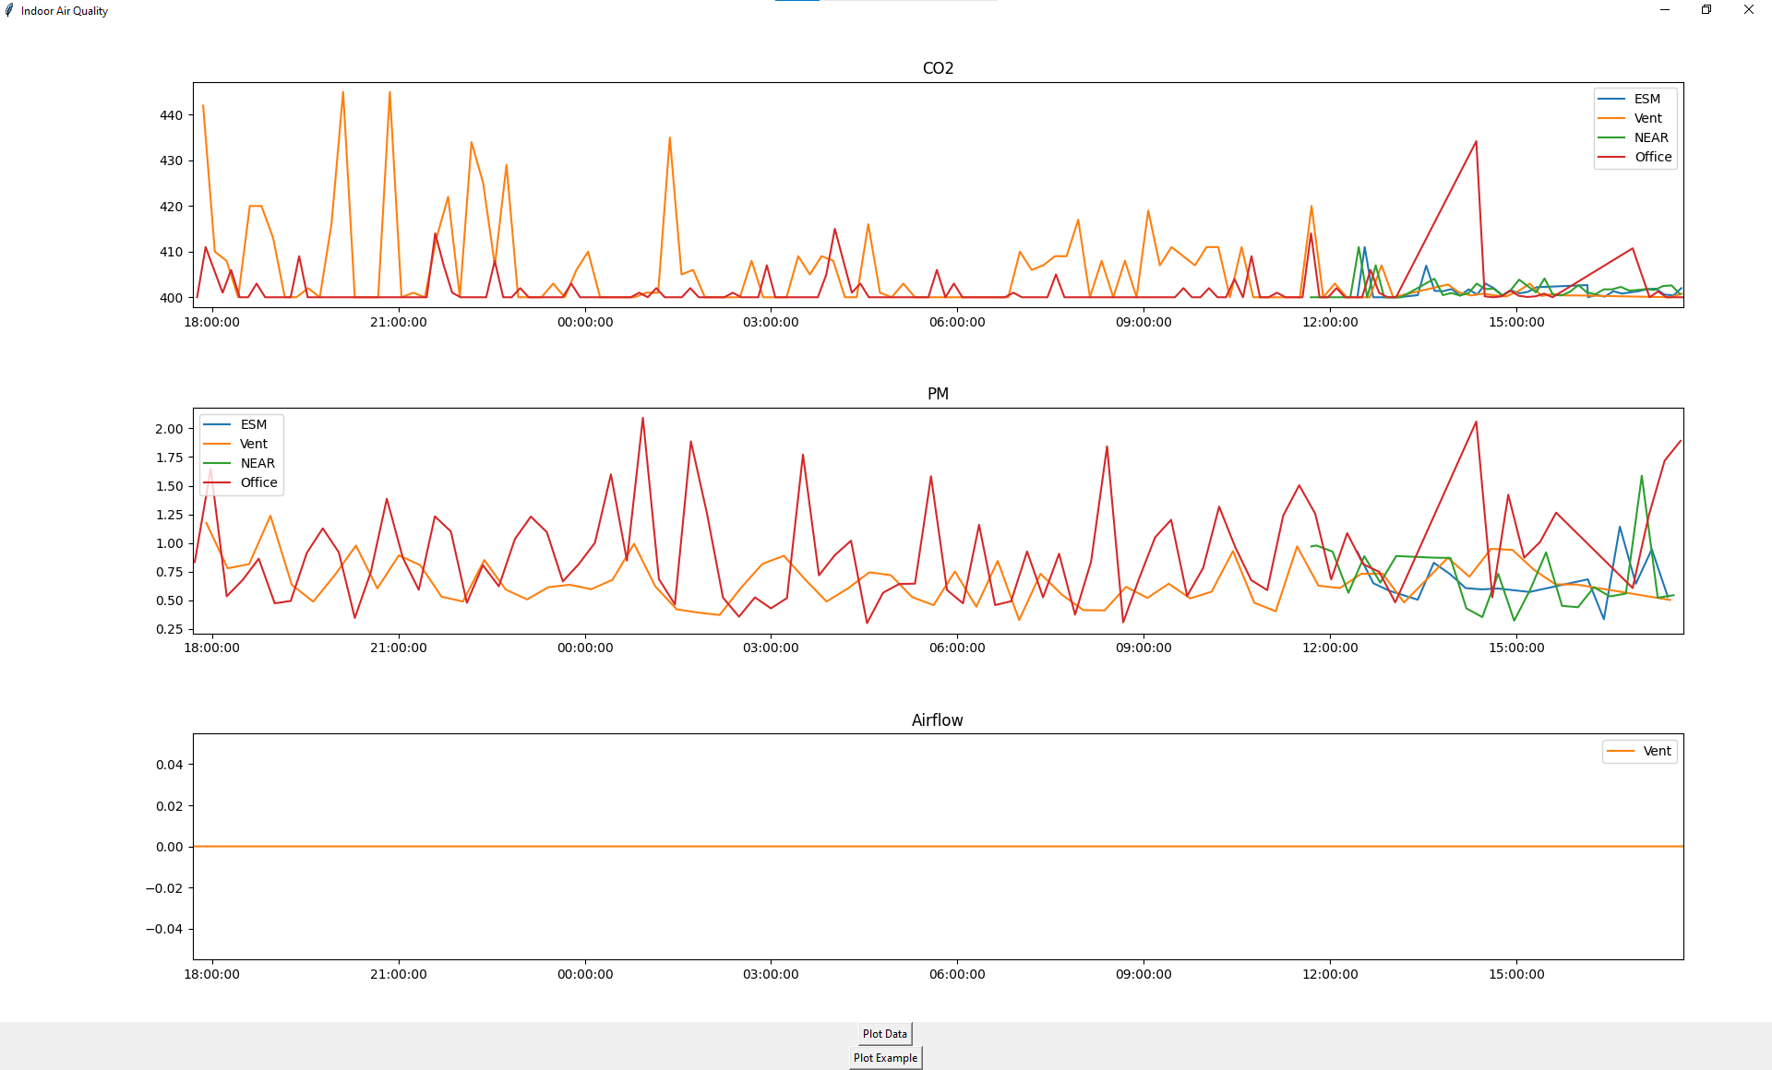

Figure Two: Graphing python script displaying data collected from 4 sensor nodes